Our Process
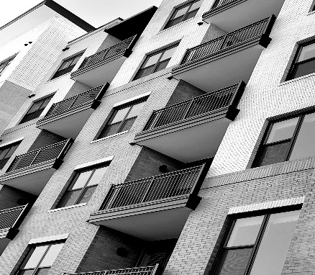

(text from about us on brochure)

Fabrication
(text from brochure)

Finish
(text from brochure)

Installation
(text from brochure)

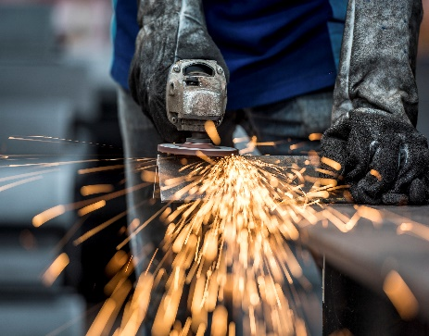 | 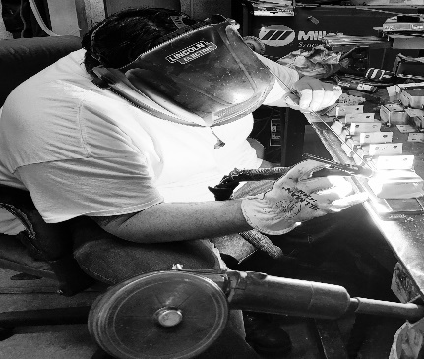 | 